

100 DAYS RTL PART-2

Day 81: D_FLIPFLOP USING SR_FLIPFLOP

Day 82: SR_FLIPFLOP USING D_FLIPFLOP

Day 83: T_FLIPFLOP USING SR_FLIPFLOP

Day 84: SR_FLIPFLOP USING T_FLIPFLOP

Day 85: D_FLIPFLOP USING JK_FLIPFLOP

Day 86: JK_FLIPFLOP USING D_FLIPFLOP

Day 87: JK_FLIPFLOP USING SR_FLIPFLOP

Day 88: SR_FLIPFLOP USING JK_FLIPFLOP

Day 89: T_FLIPFLOP USING D_FLIPFLOP

Day 90: D_FLIPFLOP USING T_FLIPFLOP

Day 81: D_flipflop Using SR_flipflop
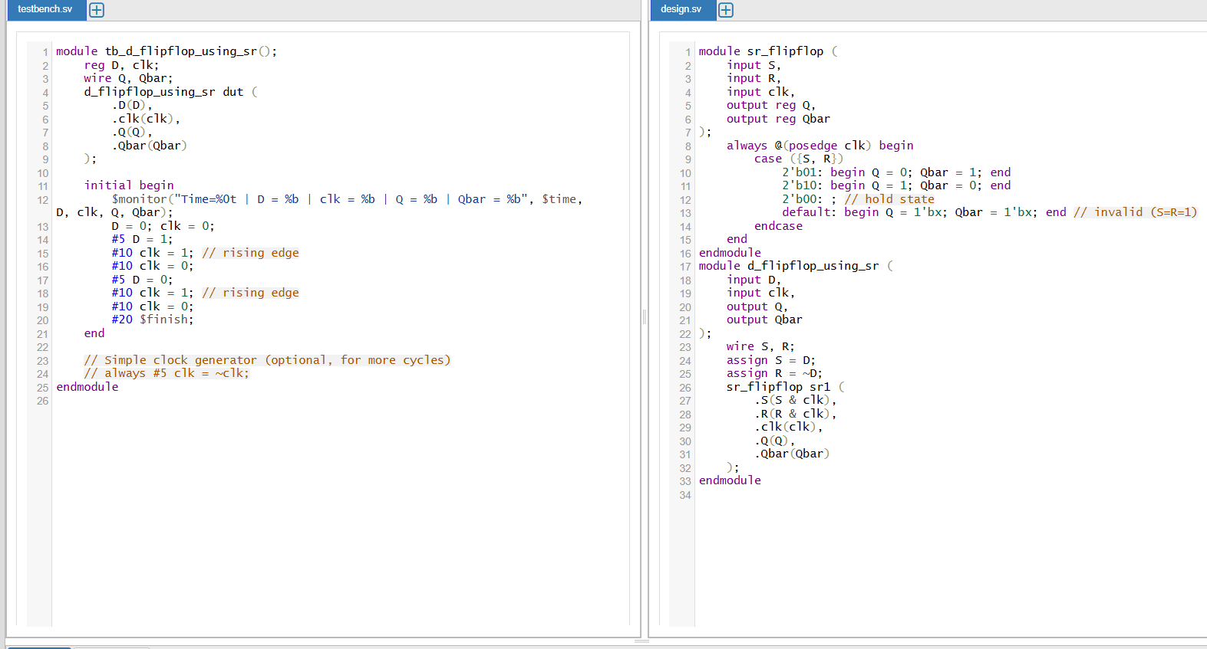

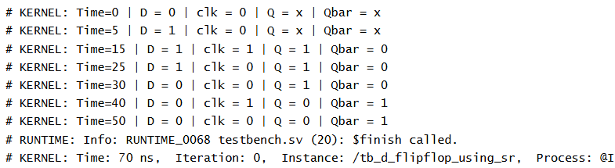
A D flip-flop is a type of sequential logic circuit that stores a single bit of data and provides it at the output, synchronized with the clock signal. It solves the ambiguity present in the SR (Set-Reset) flip-flop, where having both inputs high (S=R=1) produces an invalid state. The core principle behind using an SR flip-flop to implement a D flip-flop is to ensure that S and R are never high at the same time, which is achieved by deriving:
- S (Set) = D
- R (Reset) = D' (the complement of D)
By applying these to the inputs of the SR flip-flop, whenever the clock is active (high), the circuit behaves as follows:
- If D=1: S=1, R=0 → The SR flip-flop is set (Q=1)
- If D=0: S=0, R=1 → The SR flip-flop is reset (Q=0)
When the clock is not active, S=0 and R=0, so the flip-flop retains its prior state.
This conversion ensures that the SR flip-flop operates as a D flip-flop, reliably storing and passing along the D input value on each clock edge, and completely avoids the S=R=1 invalid state that occurs in a simple SR flip-flop. Thus, the D flip-flop is often referred to as a "data" or "delay" flip-flop, capturing the input data at every triggered (typically rising edge) clock event.
The benefits of this design include:
- Elimination of invalid states: Since only S=1, R=0 or S=0, R=1 are possible, the ambiguity or unpredictability of the SR(1,1) state is removed.
- Synchronous data storage: The output always represents the input D, sampled on the active clock transition.
- Simplified operation: The D flip-flop's characteristic equation is simply Q_next = D.
In summary, the code you provided creates a D flip-flop by feeding the D input and its inverse to the S and R inputs of an SR flip-flop, gated with the clock, ensuring reliable, edge-triggered data storage without invalid states

Day 82: SR_flipflop Using D_flipflop
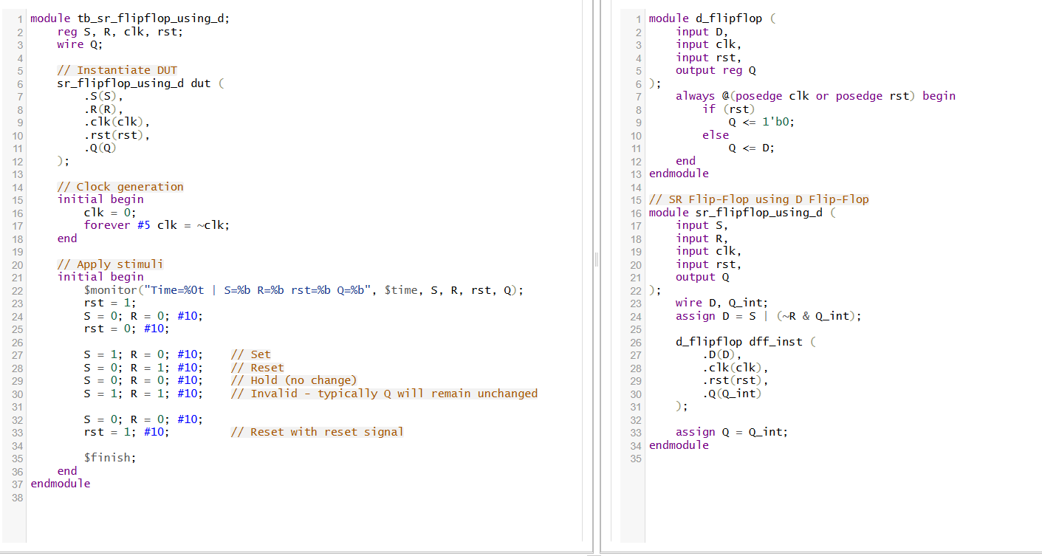
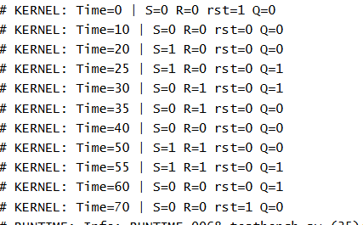
D Flip-Flop Module
- The D flip-flop is a basic sequential logic circuit used to store a single bit of data.
- It captures the input value D at the rising edge of the clock signal (clk) and holds this value stable until the next clock edge.
- Asynchronous reset (rst) is also included: when rst is asserted (high), the output Q is immediately reset to 0 regardless of the clock.
- The code uses an always block sensitive to the positive edge of clk or rst.
- If rst is high, Q is set to 0.
- Otherwise, on the rising edge of clk, Q is updated to the input D.
- This means the output Q follows the input D but only updates on clock edges, effectively "sampling" the input at discrete time points.
SR Flip-Flop Using D Flip-Flop Module
- An SR (Set-Reset) flip-flop stores a bit that can be set or reset explicitly.
- The SR flip-flop here is implemented by using the D flip-flop module as a building block.
- The logic for D input to the D flip-flop is designed from the SR inputs S (Set) and R (Reset) and the internal output Q_int.
- D = S OR (NOT R AND Q_int):
  - If S (Set) is high, D is set to 1, which will set Q on the next clock.
  - If R (Reset) is high, NOT R is 0, so D becomes 0 unless S is high, thereby resetting the output on the next clock.
  - When both S and R are low, the output holds its previous state (Q_int).
Theoretical Concepts Summarized
- Sequential Logic: Both modules are sequential circuits because their output depends not only on the current input but also on the past inputs stored in the flip-flop state.
- Edge-Triggered: The D flip-flop updates state on the rising edge of clk.
- Asynchronous Reset: The D flip-flop's state can be reset asynchronously (immediately) when rst is high.
- Functional Abstraction: The SR flip-flop is built on a lower-level D flip-flop by defining the D input in terms of S, R, and the current output state.

Day 83: T_flipflop Using SR_flipflop
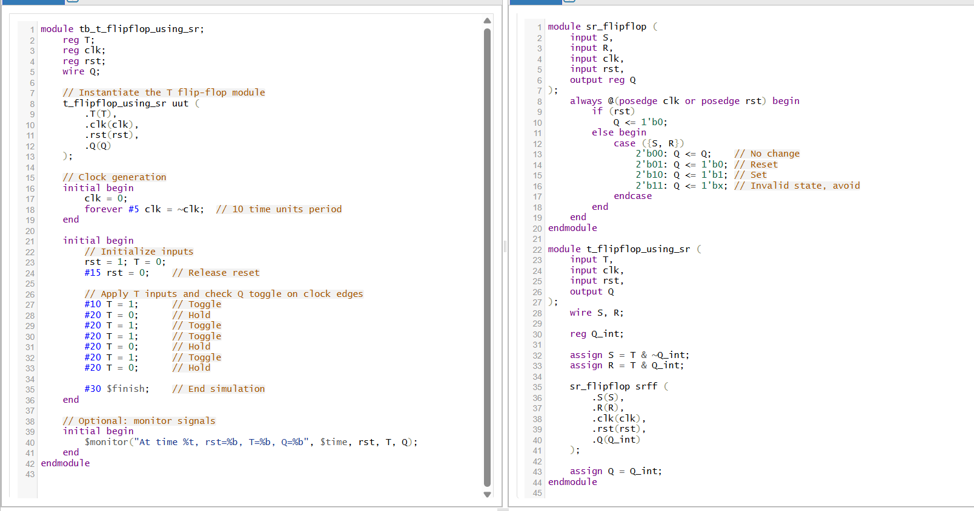
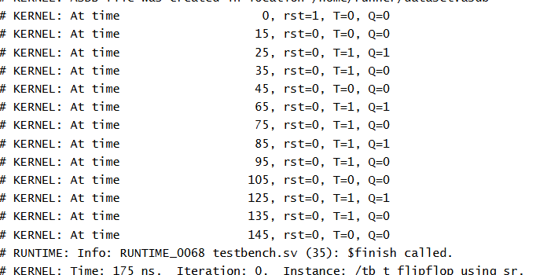
- A T flip-flop (Toggle flip-flop) has one input T and a clock. It toggles its output state (Q) on each clock pulse, if T=1. If T=0, it holds the state.
- The SR flip-flop has two inputs: S (Set) and R (Reset), with outputs Q and Q'. S=1 sets Q=1, R=1 resets Q=0, and when both are 0, the output holds its previous state. The combination S=1 and R=1 is invalid in basic SR flip-flops.
- To build a T flip-flop from an SR flip-flop:
  - The S and R inputs are controlled by the current output Q and the T input.
  - The equations for the inputs are:
    - S=T⋅Q‾S=T⋅Q (Set if T=1 and Q=0)
    - R=T⋅QR=T⋅Q (Reset if T=1 and Q=1)
  - When T=1, either S or R becomes 1 to toggle Q on the clock edge:
    - If Q=0, S=1S=1 sets the flip-flop (Q goes to 1)
    - If Q=1, R=1R=1 resets the flip-flop (Q goes to 0)
  - When T=0, S and R are both 0, so the output Q holds its state.
- This logic ensures the flip-flop output toggles on each clock cycle when T=1, implementing the characteristic behavior of a T flip-flop using SR inputs.
- The flip-flop works synchronously with the clock, updating its state at positive clock edges.
Day 84: SR_flipflop Using T_flipflop
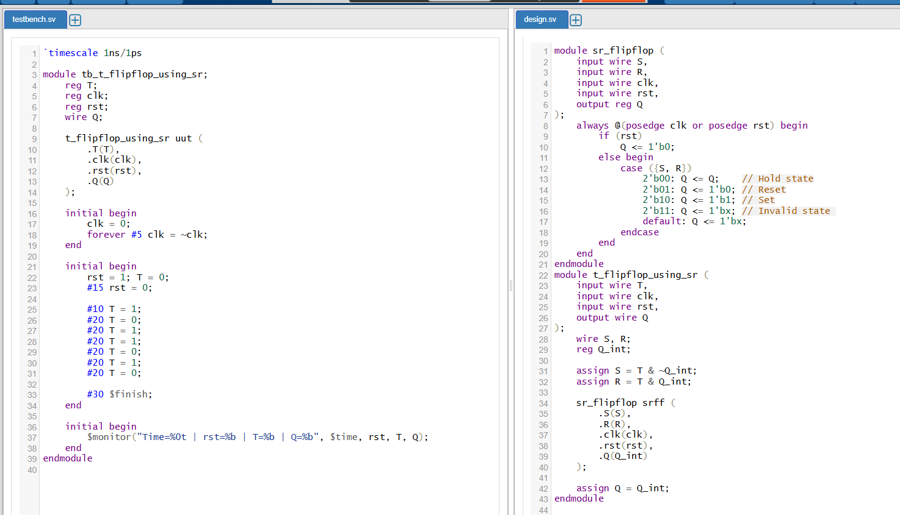
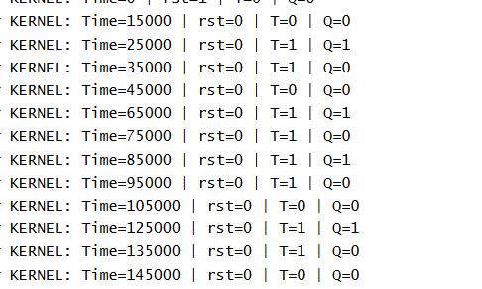

1. SR Flip-Flop Module (sr_flipflop)
- Basics:
  - The SR flip-flop (Set-Reset flip-flop) is a bistable storage element with two inputs—Set (S) and Reset (R)—and one output (Q).
  - It stores a single bit of data, changing its output according to inputs at the positive edge of the clock or asynchronously resetting when rst is asserted.
- Behavior:
  - If reset (rst) is high, the flip-flop immediately sets the output QQ to 0, overriding inputs.
  - On the rising edge of the clock (when rst is low):
    - If S=1,R=0S=1,R=0, set Q=1Q=1
    - If S=0,R=1S=0,R=1, reset Q=0Q=0
    - If S=0,R=0S=0,R=0, hold QQ at its previous state (no change)
    - If S=1,R=1S=1,R=1, this is an invalid condition, leading to an undefined state Q=xQ=x. This situation should be avoided.
2. T Flip-Flop Using SR Flip-Flop (t_flipflop_using_sr)
- Goal:
  - Implement a Toggle (T) flip-flop, which toggles (inverts) its output at every rising clock edge when T=1T=1, or holds the output unchanged when T=0T=0.
- Conversion from T to SR inputs:
The T flip-flop can be constructed using an SR flip-flop by controlling inputs SS and RR based on TT and the current state QQ as:
S=T⋅Q‾,R=T⋅QS=T⋅Q,R=T⋅Q
  - When T=1T=1, either the set or reset input goes high depending on QQ:
    - If current Q=0Q=0, then S=1S=1, causing the flip-flop to set Q=1Q=1 on the rising clock edge.
    - If current Q=1Q=1, then R=1R=1, causing the flip-flop to reset Q=0Q=0.
    - Thus, when T=1T=1, output QQ toggles.
  - When T=0T=0, both S=0S=0 and R=0R=0, so the flip-flop holds the current state QQ.
- Operation:
  - On every rising clock edge, the SR flip-flop updates its output based on SS and RR.
  - Given how SS and RR are derived, the output QQ toggles every clock cycle if T=1T=1, and holds if T=0T=0.
3. Testbench (tb_t_flipflop_using_sr)
- Purpose:
  - Verifies that the T flip-flop correctly toggles or holds output QQ based on the input TT.
  - Simulates asynchronous reset rstrst, clock signal generation, and applies varied TT inputs.
- Behavior In Test:
  - The reset signal initializes Q=0Q=0.
  - TT is toggled between 0 and 1 to check that the flip-flop toggles output on rising clock edges when T=1T=1, and maintains the output when T=0T=0.
  - Monitors signals to ensure correct response.
Day 85: D_flipflop Using JK_flipflop
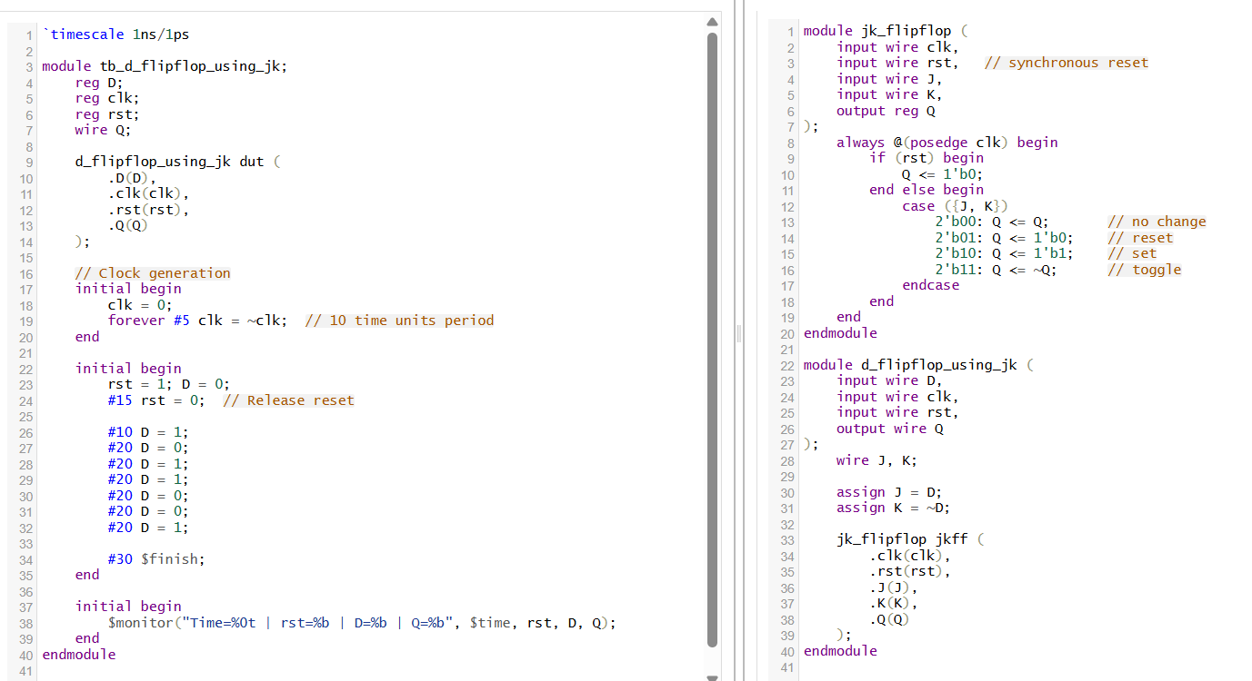
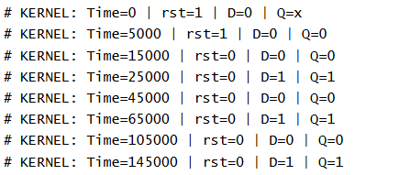
Basic Characteristics:
- A JK flip-flop has inputs JJ and KK, and output QQ. On the rising edge of the clock, the outputs change as:
  - J=0,K=0J=0,K=0: No change (hold state)
  - J=0,K=1J=0,K=1: Reset Q=0Q=0
  - J=1,K=0J=1,K=0: Set Q=1Q=1
  - J=1,K=1J=1,K=1: Toggle QQ
- A D flip-flop has a single input DD and output QQ. On the clock edge, QQ simply follows DD.
Conversion Principle:
To make a JK flip-flop behave like a D flip-flop, the inputs JJ and KK are controlled so that toggling never happens, and QQ mimics DD exactly:
J=DJ=DK=D‾K=D
- When D=1D=1:
  - J=1J=1 and K=0K=0 → Set Q=1Q=1
- When D=0D=0:
  - J=0J=0 and K=1K=1 → Reset Q=0Q=0
Thus, the JK flip-flop output QQ directly follows the DD input without any toggling.
Why this works:
- By forcing JJ and KK to never be both 1 at the same time, the toggle behavior of JK flip-flop is avoided.
Summary:
- This method relies on the excitation table and characteristic table analysis that shows how to drive JJ and KK inputs to replicate DD-flip-flop behavior.
- It is useful when only JK flip-flops are available but a D flip-flop functionality is required.
Day 86: JK_flipflop Using D_flipflop
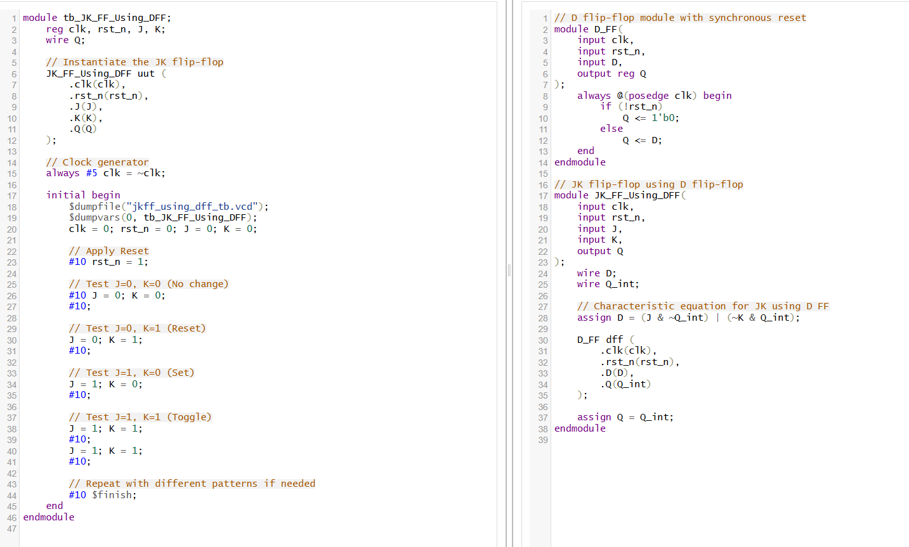
Theory Explanation:
JK Flip-Flop Overview
A JK flip-flop is a universal flip-flop that can perform the functions of Set, Reset, and Toggle based on its input signals J and K:
- When J=0, K=0: No change (hold current state)
- When J=0, K=1: Reset (output goes to 0)
- When J=1, K=0: Set (output goes to 1)
- When J=1, K=1: Toggle (output switches state)
D Flip-Flop Overview
A D (Data or Delay) flip-flop simply captures the value of its input D at the rising edge of the clock and outputs it as Q. It has no inherent Set, Reset, or Toggle modes beyond what is externally provided.
Implementing JK using D Flip-Flop
Since we only have a D flip-flop, we must express the JK flip-flop’s behavior using logic at the D input, so that the output Q of the D flip-flop behaves like a JK flip-flop.
The characteristic equation for the JK flip-flop, rewritten for the D input, is:
- D = J·(~Q) + (~K)·Q
Here,
- J and K are the JK flip-flop inputs,
- Q is the current output of the flip-flop,
- D is the input for the D flip-flop.
This equation ensures the right next state for Q, depending on J, K, and the previous Q.
How the Code Works
- D_FF module:
  - This is a simple D flip-flop with clock and synchronous reset. It stores the input D at every clock edge.
- JK_FF_Using_DFF module:
  - This module uses the characteristic equation above to compute D, using the current Q.
  - The D value is then given to the D flip-flop.
  - The output Q of the D flip-flop is used as the JK flip-flop’s output.
Essentially, the module wraps a D flip-flop with extra logic to “translate” JK inputs into proper D input changes, thus replicating a JK flip-flop's behavior.
Purpose of the Testbench
- The testbench initializes and drives the circuit, applying all input combinations (J, K) to verify correct Set, Reset, Toggle, and Hold operations on clock edges, mimicking standard JK flip-flop behavior.
Summary:
By using the characteristic equation, the code transforms JK flip-flop input behavior into an equivalent D input. The single D flip-flop, with this logic added upfront, can thus function identically to a true JK flip-flop. This demonstrates how more complex flip-flop types can be built from simpler ones using the right combinational logic.
Day 87: JK_flipflop Using SR_flipflop
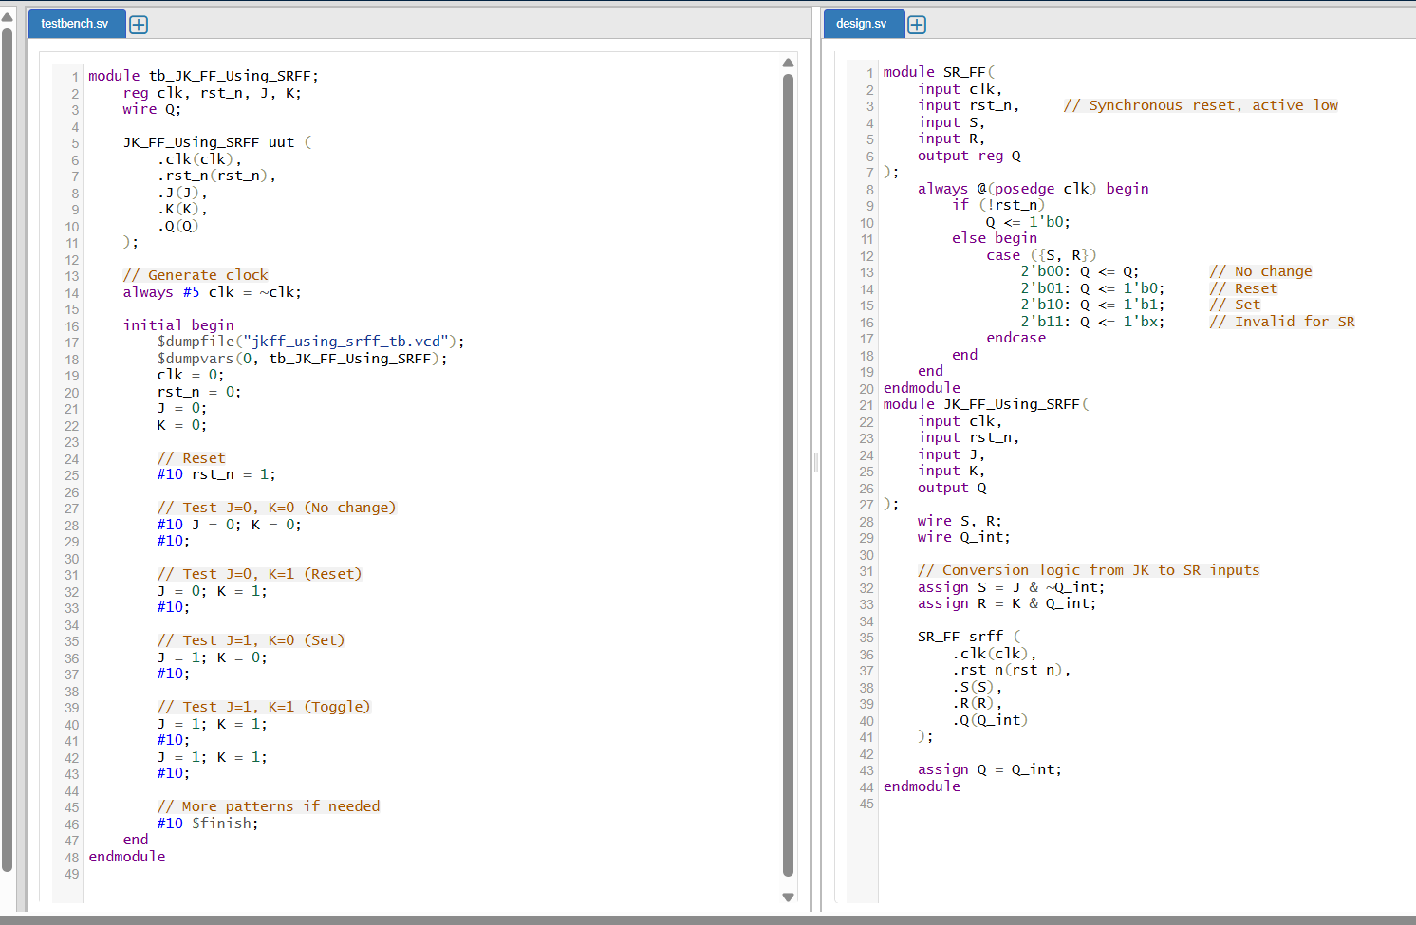
1. JK Flip-Flop Overview
A JK flip-flop is a sequential logic device with two inputs (J and K) and one output (Q). Its behavior on the clock edge is as follows:
- J = 0, K = 0: Output remains unchanged (no change)
- J = 0, K = 1: Output is reset to 0
- J = 1, K = 0: Output is set to 1
- J = 1, K = 1: Output toggles (flips) from its previous state
2. SR Flip-Flop Overview
An SR (Set-Reset) flip-flop also has two inputs (S and R) and one output (Q):
- S = 0, R = 0: Output holds its previous value (no change)
- S = 0, R = 1: Output is reset to 0
- S = 1, R = 0: Output is set to 1
- S = 1, R = 1: This is an invalid (forbidden) state as it leads to unpredictable output
3. Implementing JK Using SR Flip-Flop
To implement a JK flip-flop using an SR flip-flop, we need to express the behavior of the JK flip-flop in terms of SR inputs (S and R).
Logic Conversion:
- S (Set) = J & ~Q : S is high when J is high and output Q is low (i.e., to set the output)
- R (Reset) = K & Q : R is high when K is high and output Q is high (i.e., to reset the output)
These logic equations ensure:
- When J=K=1 (toggle): one of S or R will always be 1 depending on the current state Q, which achieves toggling by alternately setting or resetting.
- When J=K=0: neither S nor R is active, so Q holds its value.
- When only J=1 or K=1, the circuit sets or resets Q accordingly.
4. How the Code Works
- SR_FF Module:
This is a synchronous SR flip-flop with active-low reset. On each clock edge, based on S and R, Q is updated according to SR flip-flop rules (where S=R=1 yields an invalid state).
- JK_FF_Using_SRFF Module:
This module connects J and K inputs to S and R using the conversion logic above, using the current Q feedback. An internal wire Q_int is used to compute the S and R values.
- Testbench:
The testbench generates various input combinations of J and K, applies them to the circuit over time, and allows for observing the output Q in response to different JK input patterns.
5. Purpose and Behavior
By applying the logic:
- The structure enables the SR flip-flop to mimic all behaviors of a JK flip-flop, including toggle, set, reset, and hold.
- The circuit demonstrates how different flip-flops can be constructed from one another using appropriate combinational logic at their inputs.

Day 88: SR_flipflop Using JF_flipflop
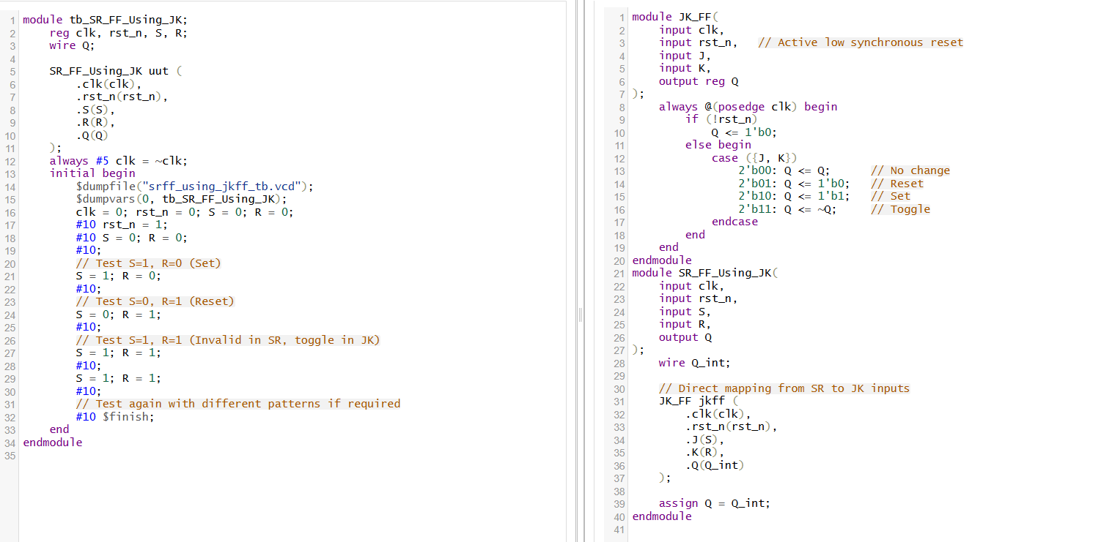
- A JK Flip-Flop module implementation (JK_FF).
- A testbench module (tb_SR_FF_Using_JK) which tests the SR flip-flop behavior using the JK flip-flop module.
Here's a detailed theory explanation for the provided code and concepts:
Theory Explanation:
1. Flip-Flops:
Flip-Flops are basic memory elements used in sequential logic circuits. They store one bit of data and have outputs that depend not only on current inputs but also on previous inputs (i.e., they have state or memory).
2. JK Flip-Flop:
- Inputs: J (set), K (reset), clk (clock), and rst_n (active low synchronous reset).
- Output: Q (state output).
Operation:
- The JK flip-flop is a refinement of the SR flip-flop. Unlike the SR flip-flop, the JK flip-flop has no invalid or forbidden states.
- The behavior on each positive edge of the clock (posedge clk) is:
  - If reset (rst_n) is active (low), the output Q is reset to 0.
  - Otherwise, the output depends on inputs J and K:
    - J=0, K=0: No change (Q remains the same).
    - J=0, K=1: Reset Q to 0.
    - J=1, K=0: Set Q to 1.
    - J=1, K=1: Toggle Q (Q becomes ~Q).
This behavior is captured in the case statement.
3. Synchronous Reset:
- rst_n is an active low synchronous reset.
- When rst_n = 0 during the clock's positive edge, Q is reset to zero.
- This type of reset synchronizes the reset signal with the clock edge, making timing predictable.
4. SR Flip-Flop Using JK Flip-Flop:
- An SR flip-flop has inputs S (set) and R (reset).
- However, it has an invalid state when both S=1 and R=1.
- To overcome this, the JK flip-flop can be used to implement an SR flip-flop:
  - J input is connected to S.
  - K input is connected to R.
5. Testbench (tb_SR_FF_Using_JK):
- The testbench tests the SR flip-flop implemented using JK flip-flop.
- It initializes the clock and reset signals.
- Multiple test cases are applied:
  - Test 1: S=1, R=0 → Set operation, Q should become 1.
  - Test 2: S=0, R=1 → Reset operation, Q should become 0.
  - Test 3: S=1, R=1 → This is invalid in SR flip-flop but valid in JK flip-flop as toggle.
  - Test 4: Repeat or extend tests with different patterns if necessary.

Day 89: T_flipflop Using D_flipflop

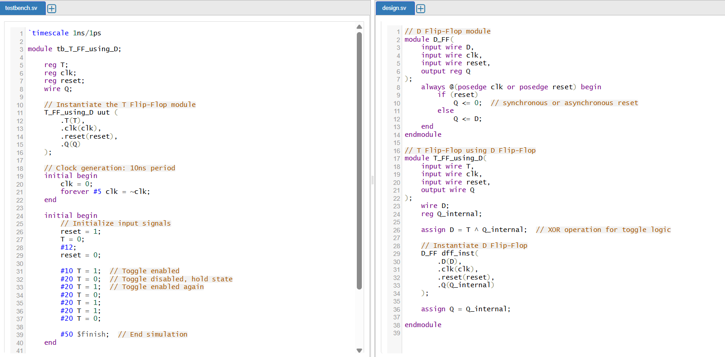

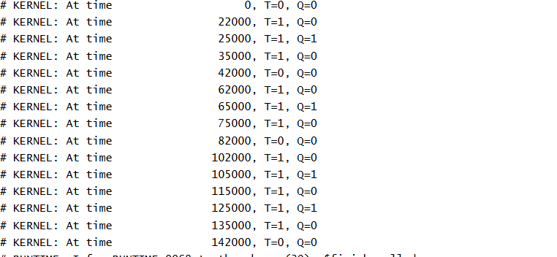
- Flip-Flop Basics:
Flip-flops are bistable circuits that store one bit of information, changing their output state on clock edges based on the input and previous state.
- T Flip-Flop (Toggle Flip-Flop):
- The T flip-flop toggles its output when the input T = 1 and holds its current state when T = 0.
- Its characteristic equation is Qnext=T⊕QQnext=T⊕Q, meaning the next state QnextQnext is the XOR of the input T and the current output Q.
- When T=0, no change occurs; when T=1, the output toggles each clock pulse.
- D Flip-Flop (Data or Delay Flip-Flop):
- Captures the input D at the clock’s rising edge and transfers it to output Q.
- The next state Qnext=DQnext=D.
- It does not inherently toggle but simply stores the input value presented at D.
- Implementing T Flip-Flop Using D Flip-Flop:
- To make a D flip-flop behave like a T flip-flop, the input D is driven by the XOR of T input and the current output Q:
D=T⊕QD=T⊕Q
- This logic ensures that when T=1, the next state toggles, and when T=0, the state holds because:
  - For T=0, D=QD=Q, so output remains unchanged.
  - For T=1, D=Q‾D=Q, so output toggles.

Day 90: D_flipflop Using T_flipflop
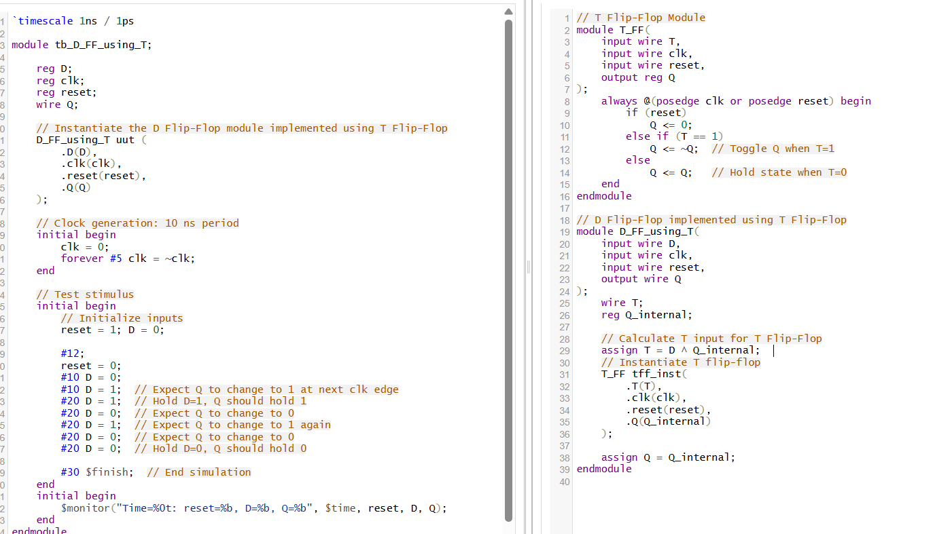
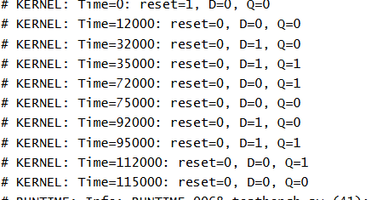
- Flip-Flop Basics:
Flip-flops are bistable elements used to store one bit of data. Their output QQ changes state depending on the input(s) and the clock edge.
- T Flip-Flop (Toggle Flip-Flop):
  - Has a single input TT.
  - When T=0T=0, the output QQ remains the same (no change).
  - When T=1T=1, the output QQ toggles state on the clock edge, i.e., Qnext=Q‾Qnext=Q.
  - Its characteristic equation:
Qnext=T⊕QQnext=T⊕Q
- D Flip-Flop (Data Flip-Flop):
  - Has a single input DD.
  - On the clock edge, the output QQ takes the value of DD, i.e., Qnext=DQnext=D.
  - It stores the input data directly.
- Conversion Logic: D Flip-Flop Using T Flip-Flop:
To implement a D flip-flop using a T flip-flop, you feed the TT input such that the toggle happens only when the current output QQ differs from the desired input DD. This makes sure that after toggling (or not toggling), the output matches DD.
Using the relation:
T=D⊕QT=D⊕Q
Explanation:
  - If D=QD=Q, T=0T=0 → no toggle; output holds the state, which already matches DD.
  - If D≠QD=Q, T=1T=1 → toggle output QQ to switch it to DD.
- Behavior on Clock Edge:
  - On each positive clock edge, the T flip-flop checks its TT input.
  - If T=1T=1, it toggles output QQ.
  - Else, QQ remains unchanged.
  - Because TT depends on D⊕QD⊕Q, this behavior ensures QQ updates to always equal DD after the clock.
- Reset Signal:
  - An active reset (usually synchronous or asynchronous) initializes QQ to a known state (often 0) to begin the operation predictably.



